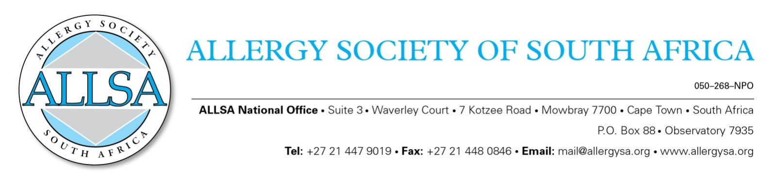

ALLSA POLICY DOCUMENT – FEBRUARY 2014

Distinguished Service Award

- Members who have served the Allergy Society of South Africa with distinction may be nominated for this award.
- They should be proposed or nominated to such membership status by a peer with a full motivation.
- A CV of the nominee must be attached.

Additional criteria that will justify such honorary membership include:
- Having served as a Congress Organiser/Chairman on several occasions;
- Having been an Editor of the Journal CACI;
- Having served on Excom for many years;
- Having provided leadership to the Society.

……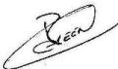…………………
Signed on this day 22 February 2014….
Chairman: ALLSA

